* Copyright for test papers and marking guides remains with *West Australian Test Papers*.
* The papers may only be reproduced within the purchasing school according to the advertised conditions of sale.
* Test papers must be withdrawn after use and stored securely in the school until Friday, 2nd December 2016.

**BIOLOGY**

**UNIT 1 & 2**

**2016**

**Name:**

**Teacher:**

**Time allowed for this paper**

Reading time before commencing work: ten (10) minutes

Working time for paper: three (3) hours

**Materials required/recommended for this paper**

*To be provided by the supervisor*

This Question/Answer Booklet

Multiple–choice Answer Sheet

*To be provided by the candidate*

Standard items: pens (blue/black preferred), pencils (including coloured), sharpener, correction fluid/tape, eraser, ruler and highlighters

Special items: non-programmable calculators approved for use in the WACE examinations

**Important note to candidates**

No other items may be taken into the examination room. It is **your** responsibility to ensure that you do not have unauthorised notes or items of a non-personal nature in the examination room. Any unauthorised material must be handed to the supervisor **before** reading any further.

**Structure of this paper**

|  |  |  |  |  |  |  |
| --- | --- | --- | --- | --- | --- | --- |
| **Section** | Number of questions available | Number of questions to be answered | Suggested working time (mins) | Marks available | Percentage of exam | % achieved |
| Section One:  Multiple-choice | **30** | **30** | **40** | **30** | **30** |  |
| Section Two:  Short answer | **5** | **5** | **100** | **100** | **50** |  |
| Section Three:  Extended answer | **4** | **2** | **40** | **40** | **20** |  |
|  |  |  |  |  |  |  |
|  |  |  |  | **Total** | **100** |  |

**Instructions to candidates**

1. The rules for the conduct of examinations for WACE courses are detailed in the *Year 12 Information Handbook 2016*. Sitting this examination implies to agree to abide by these rules.

2. Answer the questions according to the following instructions.

**Section One**: Answer **all** questions on the separate Multiple-choice Answer Sheet provided. For each question, **shade** the box to indicate your answer. Use only a blue or black pen to shade the boxes. If you make a mistake, place a cross through the square and shade your new answer. Do not erase or use correction fluid/tape. Marks **will not** be deducted for incorrect answers. No marks will be awarded if more than one answer is shaded for any question.

**Section Two and Three**: Write your answers in the spaces provided in this Question/Answer Booklet. Wherever possible, keep your answers confined to the lines provided. Use a black or blue pen for these sections. Only graphs and diagrams may be drawn in pencil.

Section Three consists of **two parts**, each with **two questions**. You must answer **one question** from **Unit 1** and **one question** from **Unit 2**. Tick the box next to the question you are answering. Do not copy the questions when writing your answer. Questions may be answered in a number of ways: tables, graphs or diagrams clearly labelled and explained, dot points with linking sentences and drawing annotated flow diagrams with introductory notes.

3. You must be careful to confine your responses to the specific questions asked and follow any instructions specific to that particular question.

4. Spare pages are included at the end of **this** booklet. They can be used for planning your responses and/or as additional space if required to continue an answer.

*Planning*: If you use the extra pages for planning, clearly indicate this at the **top** of the page.

*Continuing an answer*: If you need the extra pages to continue an answer, indicate in the **original** answer space where you continued the answer (i.e. page number). Write the question number you are continuing at the top of the spare page.

**Section One: Multiple-choice 30% (30 marks)**

This section has **30** questions. Answer **all** questions on the separate Multiple-choice Answer Sheet provided. For each question, shade the box to indicate your answer. Use only a blue or black pen to shade the boxes. If you make a mistake, place a cross through that square, then shade your new answer. Do not erase or use correction fluid/tape. Marks will not be deducted for incorrect answers. No marks will be given if more than one answer is completed for any question.

Suggested working time: 40 minutes

1. Organisms living within the soil profile belong to their own distinct food web. However, soil organisms play an important role in terrestrial ecosystems where they are classified as

(a) parasites.

(b) consumers.

(c) producers.

(d) decomposers.

2. In which part of the body are you most likely to find cells with a structure that allows a highly efficient exchange of molecules?

(a) brain

(b) small intestine

(c) heart

(d) pancreas

3. Arteries have a thick and muscular wall because

(a) they carry large quantities of blood back to the heart.

(b) they carry blood away from the heart under pressure.

(c) they contract constantly to push blood around the body.

(d) the force of gravity affects the flow of blood back to the heart.

4. A biology class was carrying out an investigation to discover whether an endangered spider orchid is present in their local woodland. What would be the most suitable method for sampling?

(a) grid quadrats

(b) random quadrats

(c) line transects

(d) photographic monitoring

Use the graph below to answer questions 5 and 6.

**Figure 1**: Stomatal conductance over a 24 hour period for *Eucalyptus vitrix*.

A scientist was measuring transpiration rate in *Eucalyptus victrix* (the ‘coolibah’ tree) that grows in the semi-arid tropical region of Western Australia. The trees varied in height, width and age. The graph above shows stomatal conductance (moisture leaving the stomata) over a 24-hour period from midnight (Time 0) to midnight (Time 24).

5. What would be the most appropriate hypothesis for this experiment?

(a) The flow of water through xylem tissue will increase with increasing UV radiation.

(b) The rate of photosynthesis will show a positive relationship with transpiration rate.

(c) Taller trees will display a greater rate of transpiration than shorter trees.

(d) The rate of transpiration will increase when exposed to increased UV radiation.

6. What is the best explanation for the data collected from 10am to 6pm?

(a) The stomata began to close thereby reducing the rate of transpiration.

(b) The roots could no longer take up water because the cells had become hypotonic.

(c) Soil moisture had declined due to the midday heat.

(d) The stomata were all open causing an increase in stomatal conductance.

7. The Western Rock lobster is a prized catch for both commercial and recreational fishers. It is a highly regulated industry with seasonal limitations on catch size, animal length and fishing area. Rock lobsters mate in late winter to early spring. The eggs hatch in shallow waters after four to eight weeks, depending on water temperature. Which of the following would have the greatest impact on rock lobster populations?

(a) over fishing

(b) climate change

(c) habitat destruction

(d) predation

8. People travelling to high altitude areas can take medication to prevent altitude sickness. On which two body systems would this medication have the most effect?

(a) cardiovascular and respiratory

(b) respiratory and digestive

(c) cardiovascular and digestive

(d) respiratory and lymphatic

9. A halophyte grows best in

(a) arid environments.

(b) acid-sulphate soil.

(c) nutrient depleted soil.

(d) saline soil.

10. Which of the following correctly matches the location of each enzyme found in the digestive tract?

|  |  |  |  |
| --- | --- | --- | --- |
| **Mouth** | **Stomach** | **Duodenum** | **Jejunum** |
| Amylase | Lipase | Protease | Amylase |
| Protease | Amylase | Lipase | Protease |
| Lipase | Protease | Amylase | Protease |
| Amylase | Protease | Lipase | Amylase |

(a)

(b)

(c)

(d)

11. The four basic tissue types found in animals are

(a) muscle, connective, nervous and epithelial.

(b) muscle, adipose, connective and skin.

(c) connective, epithelial, adipose and lymphatic.

(d) epithelial, lymphatic, muscle and nervous.

12. The correct hierarchy for increasing cellular organisation is

(a) cells 🡪 tissues 🡪 systems 🡪 organs

(b) cells 🡪 tissues 🡪 organs 🡪 systems

(c) systems 🡪 organs 🡪 tissues 🡪 cells

(d) organs 🡪 systems 🡪 tissues 🡪 cells

The following diagram of an animal cell relates to questions 13 to 16.

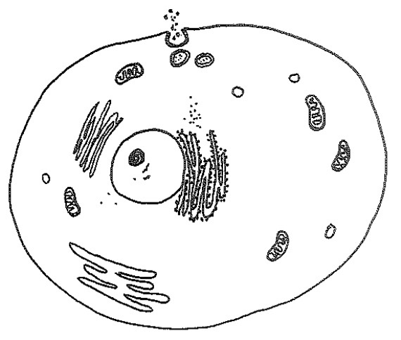

F

J

I

G

H

13. What is the organelle labeled **H**?

(a) endoplasmic reticulum

(b) golgi apparatus

(c) nucleus

(d) mitochondria

14. In which organelle does cellular respiration occur?

(a) H

(b) F

(c) G

(d) I

15. What process is occurring in the area labelled J?

(a) endocytosis

(b) exocytosis

(c) phagocytosis

(d) pinocytosis

16. If the cell belonged to a plant, three structures/organelles that would be present are the

(a) vacuole, cell wall and nucleolus.

(b) cell membrane, vacuole and chloroplasts.

(c) cell wall, chloroplasts and lysosomes.

(d) chloroplasts, cell wall and vacuole.

17. Lactic acid is produced by cells when

(a) there is limited light available.

(b) water is unavailable.

(c) oxygen is unavailable.

(d) the stomata are closed.

Refer to the diagram of a human heart below to answer questions 18 and 19.

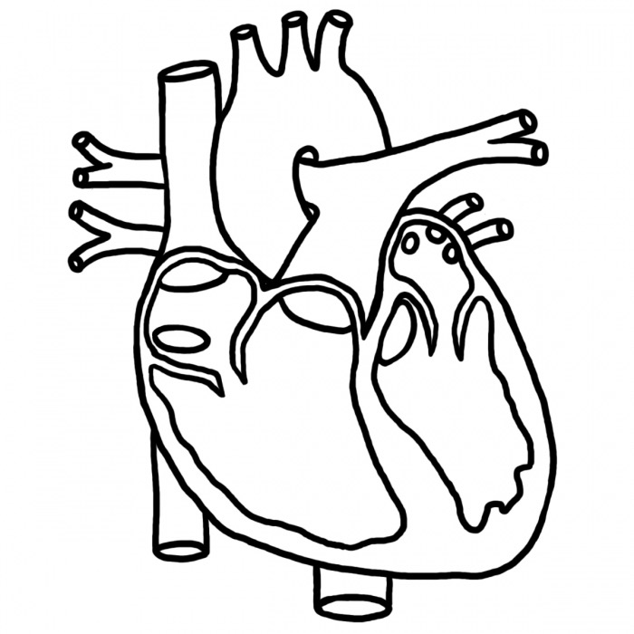

18. A deoxygenated blood cell is about to enter the heart. What path does the cell take until it leaves as an oxygenated blood cell?

(a) left atrium, left ventricle, pulmonary artery, lungs, pulmonary vein, right atrium, right ventricle, aorta.

(b) right atrium, right ventricle, pulmonary artery, lungs, pulmonary vein, left atrium, left ventricle, aorta.

(c) left atrium, left ventricle, aorta, lungs, pulmonary vein, right atrium, right ventricle, pulmonary artery.

(d) pulmonary vein, lungs, right atrium, right ventricle, pulmonary artery, left atrium, left ventricle, aorta.

19. The function of the semilunar valve is to prevent

(a) blood mixing between ventricles.

(b) oxygenated blood getting into the lungs.

(c) blood from flowing back into the right ventricle.

(d) blood from flowing into the right atrium.

20. A fish heart is different to a mammal’s heart in that it has

(a) a two-chambered heart with two ventricles.

(b) one muscular chamber that pumps blood in one direction.

(c) a two-chambered heart with one atria and one ventricle.

(d) a four-chambered heart with no valves.

21. Fungi cannot be classified with plants because they

(a) contain a cell wall.

(b) do not contain chlorophyll.

(c) cannot photosynthesise.

(d) are decomposers.

22. If a plant cell is very hypotonic compared to its surroundings, then

(a) water will enter the cell causing it to swell and become turgid.

(b) the contents of the cell are much more concentrated than the external environment.

(c) the contents of the cell are less dilute than the external environment.

(d) the cell will become flaccid and plasmolysis could occur.

23. Many invertebrates have an open circulatory system. Which of the following statements best describes how this system works?

(a) Internal fluid washes freely over internal structures.

(b) An open-ended vessel pumps fluid from one segment to the next.

(c) A heart pumps internal fluid into the central cavity, which is then distributed to other parts of the body through a network of vessels.

(d) A two-chambered heart directs deoxygenated blood to the skin where it obtains oxygen.

24. If the rate of growth of a population is increasing, then it is likely that

(a) births are increasing and immigration is decreasing.

(b) immigration is increasing and deaths are increasing.

(c) births are increasing and emigration is decreasing.

(d) deaths are decreasing and immigration is decreasing.

The diagram below relates to question 25 and 26.

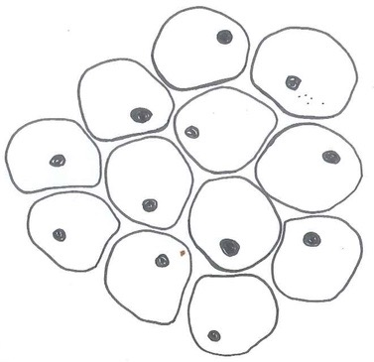

x400

10 um

25. What is the average width of a cell in the diagram above?

(a) 10 um

(b) 7 um

(c) 3 um

(d) 5 um

26. If the magnification is increased to x1000 and the ocular lens is x10, the objective must be

(a) x 10

(b) x 100

(c) x 20

(d) x 1000

27. The vascular system of plants is similar to that of mammals in that it

(a) circulates fluid around the plant in order to maintain structural integrity.

(b) is comprised of veins that distribute water around the plant.

(c) transports water, nutrients, and important substances to the cells for metabolic purposes.

(d) carries water and solutes in different vessels to structures where they are most required.

28. Proteins are the end product of a series of complicated reactions. Each protein has a specific three-dimensional structure. The primary structure of a protein is most dependent on

(a) ribosome function

(b) amino acid sequencing

(c) messenger RNA

(d) DNA transcription

29. DNA is comprised of subunits called

(a) nucleic acids.

(b) genes.

(c) nucleotides.

(d) bases.

30. ATP, the molecule that fuels chemical reactions, stands for

(a) adenine triphosphate.

(b) adenosine triphosphate.

(c) alanine tetraphosphide.

(d) adenosine triphosphide.

**End of Section One**

**Section Two: Short Answer**  **50%** (**100 marks)**

This section has **five (5)** questions. Answer **all** questions. Write your answers in the spaces provided.

Spare pages are included at the end of this booklet. They can be used for planning your responses and/or as additional space if required to continue an answer.

* + Planning: If you use the spare pages for planning, indicate this clearly at the top of the page.
  + Continuing an answer: If you need to use the space to continue an answer, indicate in the original answer space where the answer is continued, i.e. give the page number. Fill in the number of the question(s) that you are continuing to answer at the top of the page.

Suggested working time: 90 minutes.

**Question 31 (20 Marks)**

(a) In the space below, draw a labelled diagram of the fluid mosaic model of a cell membrane. The diagram must include proteins embedded within the membrane for molecular transport. (6 marks)

(b) Identify **two** organelles within plant and animal cells that contain this type of membrane. (2 marks)

(c) Animal cells contain cholesterol molecules within the membrane. What is the structural importance of this molecule to the membrane? (2 marks)

(d) Differentiate between the terms diffusion and osmosis. (2 marks)

(e) Using examples, explain why specific molecules can pass easily through the cell membrane while others cannot. (4 marks)

(f) Describe the differences between active transport and facilitated diffusion. (4 marks)

**Question 32 (20 marks)**

Consider the diagram below of a cellular process that occurs in plants.



(a) (i) State the name of the process in the diagram above. (1 mark)

(ii) Write a balanced overall equation for this process. (3 marks)

(b) (i) In which organelle does this process take place? (1 mark)

(ii) In which section of this organelle do the following reactions take place? (2 marks)

Light-dependent

Light-independent

(c) Identify the inputs and outputs for the two reactions of this cellular process. (8 marks)

**Light-dependent reactions**

|  |  |
| --- | --- |
| Input A |  |
| Output A |  |
| **Light-independent reactions** | |
| Input B |  |
| Output B |  |

(d) Explain how reducing exposure of the plant’s cells to light would affect the plant’s metabolic processes. (3 marks)

(e) This cellular process can be compromised during times of drought. Describe **two** adaptations of Australian plants that enable normal function with limited water. (2 marks)

**Question 33 (20 marks)**

Enzymes are critical to the survival of all living things.

(a) Define the term enzyme and state why enzymes are critical for survival. (2 marks)

(b) In the space provided, draw a labelled diagram of the **lock-and-key** model of enzyme function for an **anabolic** reaction. (6 marks)

(c) Identify **two** factors that affect enzyme function. (2 marks)

A biology class were learning about the immune system and fever. They were keen to find out why a fever could be fatal.

(d) Using your knowledge of enzyme function, design an experiment to test the effect of fever on the human body.

(i) Hypothesis (2 mark)

(ii) Independent variable (1 mark)

(iii) Dependent variable (1 mark)

(iv) Controlled variables (2 marks)

(v) Methodology (4 marks)

**Question 34 (20 marks)**

The Hairy Marron (*Cherax cainii*) is endemic to southwest Western Australia and one of the only two species of marron in the world. The Margaret River Hairy Marron population is under threat and has been listed as “fauna that is likely to become extinct” under our State legislation, and “critically endangered” on both the federal and IUCN lists. Unlike the Smooth Marron, the Hairy Marron has hair-like setae that cover its carapace. The two species of marron were not identified as genetically distinct until 2002. It is believed that the smooth marron invaded the Margaret River in the early 1980s, and have been interbreeding with their hairy relatives. Hairy Marron are now only found in pools of the upper reaches of Margaret River and undisturbed woodland. While marron fishing is banned in these areas, enforcement of fishing regulations is difficult due to the remote location and limited resources.

(a) Identify **two** reasons why it is important to save the Hairy Marron? (2 marks)

(b) What is the most likely explanation for the appearance of Smooth Marron in Margaret River in the 1980s? (2 marks)

(c) Identify and explain the **three** greatest threats to the recovery and survival of the Hairy Marron in Margaret River. (6 marks)

(d) Explain why breeding of Hairy Marron “brood stock” may be problematic to conservation efforts. (4 marks)

(e) Describe how smooth marron populations could be effectively removed from the Hairy Marron’s habitat and suggest why this is important to the continuation of the Hairy marron as a species. (2 marks)

(f) Outline the **four** most appropriate methods for monitoring freshwater animal populations that are similar to the Hairy Marron. (4 marks)

**Question 35 (20 marks)**

(a) Describe the major functions of the four main processes of the gastrointestinal system listed in the table below. (4 marks)

|  |  |
| --- | --- |
| **Process** | **Function** |
| Ingestion |  |
| Digestion |  |
| Absorption |  |
| Egestion |  |

(b) Describe why the function of the pancreas is crucial for digestion. (2 marks)

(c) Define the term peristalsis. (2 marks)

(d) Explain how the structure of the small intestine helps to increase the absorption of nutrients into the bloodstream. (4 marks)

Some organisms possess a large caecum in their digestive tract.

(e) (i) What is the main diet of an organism with a large caecum? (1 mark)

(ii) Describe how a caecum functions in order to aid digestion in these organisms.

(3 marks)

(f) Crohn’s Disease is a disease of the digestive system that causes inflammation and the formation of large ulcers in the small intestine. Describe **four** **symptomatic effects** that this may have on the health of an individual diagnosed with Chrohn’s. (4 marks)

**End of Section Two**

**Section Three: Extended Answer 20% (40 marks)**

This section contains **Unit 1** questions and **Unit 2** questions, in two parts. You must answer **two (2)** questions, **one question** from **Unit 1** and **one question** from **Unit 2**. Please place a tick in the box next to the question you are answering. Write your answers in the space provided.

Spare pages are included at the end of this booklet. They can be used for planning your responses and/or as additional space if required to continue an answer.

* + Planning: If you use the spare pages for planning, indicate this clearly at the top of the page.
  + Continuing an answer: If you need to use more space to continue an answer, indicate in the original answer space where the answer is continued, i.e. give the page number. Write the number of the question(s) that you are continuing to answer at the top of the additional space page.

Responses may include clearly labelled diagrams with explanatory notes; lists of points with linking sentences; clearly labelled tables and graphs; and annotated flow diagrams with introductory notes.

Suggested working time: 50 minutes

**Unit 1 –** Choose either **Question 36** or **Question 37**.

**Question 36 (20 marks)**

Over the last century, the health of many ecosystems has been negatively affected as a result of human impact.

(a) Describe how and why the use of pesticides and industrial pollutants has had an ongoing negative effect on species and ecosystems. You must ensure that you use examples to support your answer. (10 marks)

Many species that have been introduced into the Australian environment have become pests. The control and/or eradication of most pest species is problematic for both agriculture and natural resource management.

(b) Using a specific example, describe the effect of the introduction of an invasive animal species on the ecosystem in which it lives. (10 marks)

**OR**

**Question 37 (20 marks)**

Individual species are influenced by both biotic and abiotic factors in the environment.

(a) Describe how naturally occurring abiotic factors in the environment affect spatial and temporal distribution and the abundance and diversity of a given species. Ensure that you incorporate specific examples to support your answer. (10 marks)

Natural disasters can be detrimental to both populations of species and entire ecosystems.

(b) Describe the beneficial effects of fire (non-prescribed) on a terrestrial ecosystem. Outline the adaptations of native Australian plants to cope with the effects of fire and assist with growth and development. (10 marks)

Question number:

Question number:

Question number:

**Unit 2 -** Choose either **Question 38** or **Question 39**.

**Question 38 (20 marks)**

Most animals obtain their oxygen requirements from the surrounding air. Unlike energy, oxygen cannot be stored and therefore must be continually obtained from the environment.

(a) Describe how breathing occurs in the mammalian lung. Identify the requirements for efficient gas exchange by referring to specific structures used throughout this mechanism. (10 marks)

All animals possess adaptations to increase the exchange of gases with their external environment. Unlike their terrestrial ancestors, aquatic animals are specially adapted to obtain oxygen from the water.

(b) Describe the mechanism of gas exchange for bony fish. Compare gas exchange in bony fish with gas exchange in mammals. (10 marks)

**OR**

**Question 39 (20 marks)**

The production of energy is essential for life.

(a) Outline the three main processes involved in the production of ATP during aerobic cellular respiration. Identify where each process occurs, the chemical reactions that take place and total energy yields. Annotated diagrams may be useful in your response. (10 marks)

Energy production can be affected by a number of factors that can change how the process takes place, the chemical reactions that occur and the amount of energy produced.

(b) Describe the process of anaerobic cellular respiration. Identify what influences the onset of this process and describe the outputs for both plant and animal cells. (10 marks)

Question number:

Question number:

Question number:

**Acknowledgements**

**Question 5 & 6**

Graph of transpiration rates – by author.

**Questions 13 – 16**

Animal cell diagram – by author.

**Questions 18 & 19**

Diagram of human heart - <a href="http://cliparts.co">Clip arts</a>

**Question 25 & 26**

Microscope cell diagram – by author.

**Question 32**

Diagram - by author.